STOPWATCH ASSIGNMENT

**Topic: HTML, CSS & Javascript**

**Assignment Description** - Build a stopwatch using HTML/CSS and JavaScript. The stopwatch should have a display field showing the current time, as well as buttons for starting, pausing, resetting, and casting time.

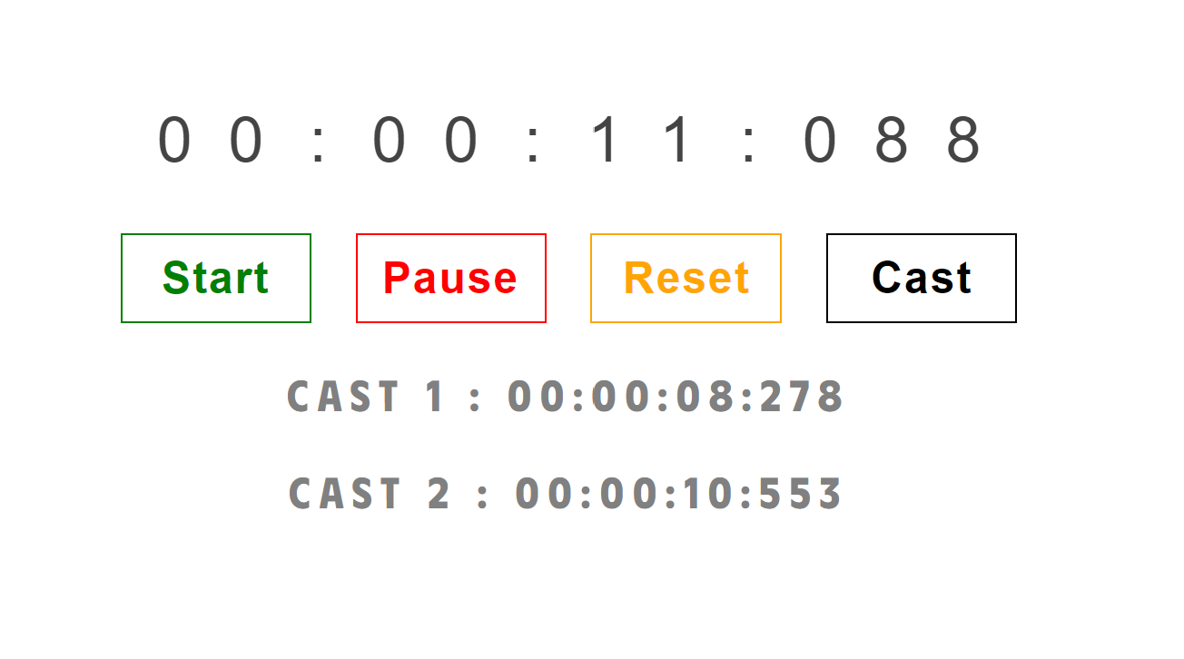

**Note:**

* UI should not mandatory look like above pic. You may create your own UI or add some hovering or clicking effect. But functionality should be the same. (if you’re creating your own ui, make sure it looks better than above one)
* This is a **HTML/CSS, and JavaScript assignment**, and it should be done using these three languages.
* If you submit your assignment using ***ReactJS it’ll not be considered for evaluation***
* The time format should be in hours, minutes, seconds, and milliseconds (HH:MM:SS:MS).

### **Test Cases**

| Test Case 1 :  Initially there should be a display field with the initial timer set to "00:00:00:000".  There should be four buttons: Start, Pause, Reset, and Cast. |
| --- |
| Test Case 2: Start Button:  When the user clicks the Start button, the timer should begin running. |
| Test Case 3 : Cast Button:  When the user clicks the Cast button, the time that is currently displayed on the stopwatch should be casted at the below section in the format "CAST {Index of cast button} -{Timer at the time of button press}"    Note: The time format should be in hours, minutes, seconds, and milliseconds (HH:MM:SS:MS). |
| Test Case 4 : Pause Button:  When the user clicks the Pause button, the timer should stop running. |
| Test Case 5 : Reset Button:  When the user clicks the Reset button, the timer should be reset to "- 00:00:00:000".     * The timer should reset back to - 00:00:00:000 * If you have casted time before, it should be reset to None. |

**Submission Steps:**

1. Create a folder named `stopwatch_assignment`
2. `stopwatch_assignment` should contain three folders
   1. Html/css files
   2. Javascript file
   3. Image folder containing Screenshot of final output
3. Compress your folder to zip file and submit it

You can use the document below as a guide to learn [how to zip a folder](https://docs.google.com/document/d/1wLV5j5eNMfY5GQ05R6ApCdqOEkb-1gbIALb3QYEWLJk/edit?usp=sharing) and [how to submit in a feedback form](https://docs.google.com/document/d/1wLV5j5eNMfY5GQ05R6ApCdqOEkb-1gbIALb3QYEWLJk/edit?usp=sharing) : [Steps for submitting in a Feedback Form](https://docs.google.com/document/d/1wLV5j5eNMfY5GQ05R6ApCdqOEkb-1gbIALb3QYEWLJk/edit?usp=sharing)